

| **TITLE**: Introduction and Implementation using SPARK AR |
| --- |

**AIM:**

1. Install the Spark AR
2. Design the social media filter (Sample example as follows)
   1. Tattoo
   2. Scars
   3. Avatar
   4. Hairdressing accessories
   5. Magical powers (Ex. Laser through eyes)
   6. Students choice
3. Demonstrate the filter through camera of mobile or laptop or system

**______________________________________________________________________**

**Expected OUTCOME of Experiment:**

CO3: Implement Clipping,3D Geometric Transformations and 3D viewing

CO4: Understand the computer Input & interaction, Curves and Computer Animation

**_____________________________________________________________________**

**Books/ Journals/ Websites referred:**

<https://www.youtube.com/watch?v=2ypJ9CFOK5U&list=PLTgRMOcmRb3Nx2LF5EHU4MtmpAQBafVgE&index=1&ab_channel=Packt>

**_____________________________________________________________________**

**Write the hardware/software requirement of installation.**

**Provide the pictures (Minimum 3 picture + 1 picture while you’re handling the hardware).**

**Provide the code, screenshot and photographs**

Processor: Intel Core i5 or equivalent (for smooth performance).

Memory (RAM): Minimum 8 GB RAM (recommended 16 GB for handling multiple applications).

Graphics Card: Integrated graphics (for basic performance), recommended a dedicated GPU like NVIDIA GeForce GTX 1050 or better for enhanced AR rendering.

Storage: 2 GB available disk space for installation files and cache (SSD recommended for faster performance).

Display: Minimum 1280x768 screen resolution.

Camera: Integrated or external webcam for real-time filter testing.

Network: Active internet connection for accessing SparkJS and Instagram APIs.

Software Requirements:

Operating System:

Windows: Windows 10 (64-bit) or higher.

Mac: macOS 10.13 High Sierra or later.

Development Tools:

Node.js: Version 14.x or higher for running the SparkJS framework.

npm: Latest version to manage dependencies and run builds.

Spark AR Studio: Required for testing, exporting, and uploading filters to Instagram.

Browser: Google Chrome, Mozilla Firefox, or any modern browser for accessing SparkJS documentation and debugging tools.

**Steps to perform:**

**Drive or GitHub link:**

[**https://drive.google.com/file/d/1pFYz-XjOtuuTVRgIxzYll8ABNVaVLBXe/view?usp=sharing**](https://drive.google.com/file/d/1pFYz-XjOtuuTVRgIxzYll8ABNVaVLBXe/view?usp=sharing)

**Output(s) (Screen Shots):**

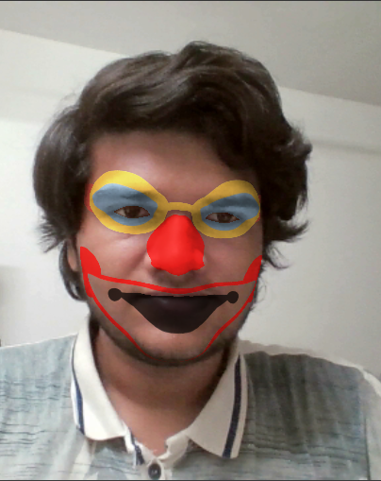

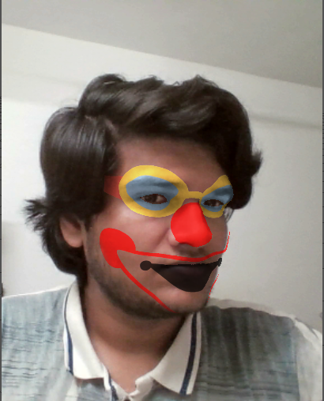

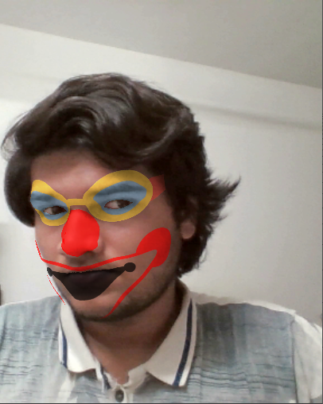

**Conclusion and discussion:**

The project successfully demonstrates social media filter creation using Spark AR, showcasing interactive designs through camera-based effects.

**Date:**

**Signature of faculty in-charge**